Temporary Engineering Change Request Information
TECN Number: |  | ECN Title: | Communication System PID Monitoring
Date: | 5/09/2018 | ECN Originator: | Hyundai Rotem/Woojin/DTS
ECN Schedule: | ASAP | Component Effected: | Communication System/PID

Temporary Engineering Change Request Description
Hyundai Rotem and the communication system supplier, Woojin, are investigating the random and constant
PID Power failures that have been experienced over the past year of revenue service.
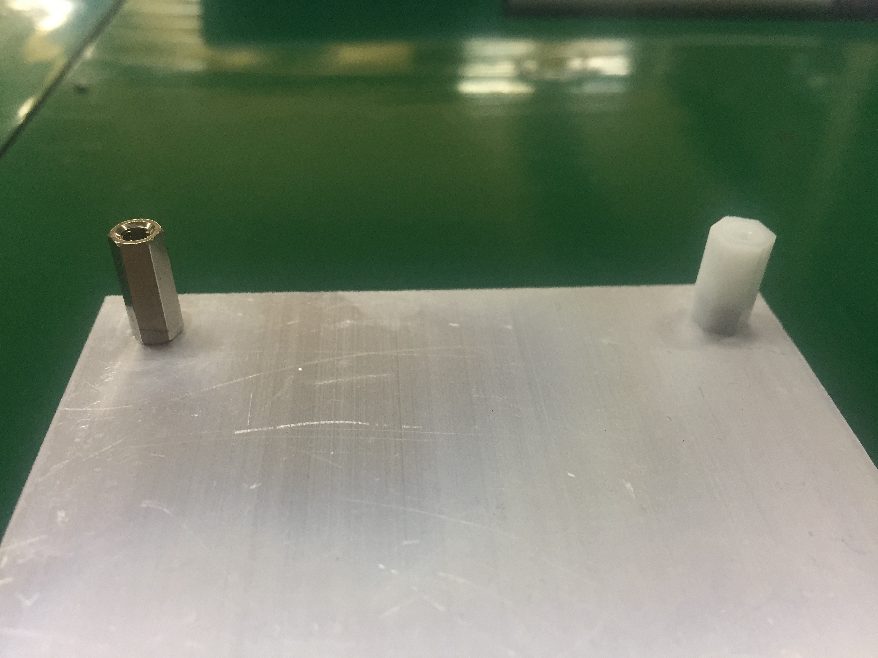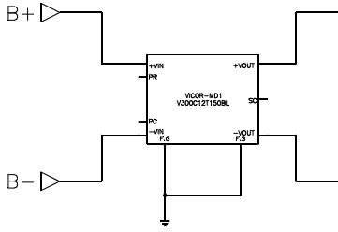
Before
(stainless material)
after
(Polyacetal material)
<PID Power Support>
Noise blocking.
VICOR 모듈
우진은 파워 모듈 업체(VACOR)와 함께 원인 분석을 실시 하였으며, 파워 FG를 통해 노이즈가 입력되어 불량이 발생
한다고 추정하고 있다. 따라서 우진은 보완 방안으로 차량 FG 노이즈 차단 방밥을 적용 하려고 한다
우진은 고장이 발생한 차량중 4035-4036,4047-4048 차량에 작업을 하기를 희망하며 2달간 모니터링을 통해 완벽한 솔루션을 찾을 것이다.작업은 한편성당 1Day 소유된다.

Temporary Engineering Change Required Documents
 | Required | Supplied
Work instructions:
Design drawings:
Technical description:
Maintenance manual:
Parts list / manual:
Test plan:
Test procedures:
Interface documents:
Communication plan:

DTO Configuration Management Board Approval
Title | Date | Approved (Y/N) | Printed Name | Signature
General Manager |  |  | Anne Herzenberg
Chief Engineer |  |  | Mario Santiago
Chief Transportation Officer |  |  | Frank Hauser
Chief Mechanical Officer |  |  | Carl Atencio
Chief Safety Officer |  |  | Barry McGauley

Disposition (Circle the one that applies)
Approved As Submitted | Approved With Modifications | Rejected See Attached Explanation | Resubmit Changes Required

Distribution Instructions:
Original – DTO Document Control Permanent Record
1 copy DTO Chief Engineer 1 copy DTO Chief Mechanical Officer
1 copy DTO Chief Transportation Officer 1 copy – Originator

